|  |  |  |
| --- | --- | --- |
| SKYLINE BOOK STORE  Skyline.in | ENROLLMENT NO : 14159  Name : Dhanush Kumar s   |  | | --- | | INCHARGE : Mr.ARUN KUMAR |   COURSE : HDFD |

*HTML Program*

<!DOCTYPE html>

<html lang="en">

<head>

<meta charset="UTF-8">

<meta name="viewport" content="width=device-width, initial-scale=1.0">

<title>Book Store</title>

<link rel="stylesheet" href="C:/Users/sugun/Downloads/project skyline/cskyline.css">

</head>

<body>

<div class="mainheading">

<h1 id="heading">Skyline Book Store</h1>

<h4>Skyline.in</h4>

</div>

<div class="rollover">

<marquee direction="scroll">%Exciting Summer Offers Are Closing Soon.., Hurry Up Now!!!</marquee>

</div>

<nav>

<div class="nav">

<ul>

<li><a target="_self" href="#heading">Home</a></li>

<li><a target="_self" href="#newarrivals">New Arrivals</a></li>

<li><a target="_self" href="#popular">Popular</a></li>

<li><a target="_self" href="#offerzone">Offer Zone</a></li>

<li><a target="_self" href="#@99only">@99 Only</a></li>

<li><a target="_self" href="#aboutus">About Us</a></li>

</ul>

</div>

</nav>

<div class="split">

<div class="genre">

<h2 class="sidebarhead">Genre's:</h2>

<ul>

<li><a target="_self" href="C:/Users/sugun/Downloads/project skyline/Educational.html">Educational</a></li>

<li><a target="_self" href="C:/Users/sugun/Downloads/project skyline/Business.html">Business</a></li>

<li><a target="_self" href="C:/Users/sugun/Downloads/project skyline/Fiction.html">Fiction</a></li>

<li><a target="_self" href="C:/Users/sugun/Downloads/project skyline/Romance.html">Romance</a></li>

<li><a target="_self" href="C:/Users/sugun/Downloads/project skyline/Biographies.html">Bio-graphies</a>

</li>

<li><a target="_self" href="C:/Users/sugun/Downloads/project skyline/Comics.html">Comics</a></li>

<li><a target="_self" href="C:/Users/sugun/Downloads/project skyline/Politics.html">Politics</a></li>

<li><a target="_self" href="C:/Users/sugun/Downloads/project skyline/Casestudies.html">Case Studies</a>

</li>

</ul>

</div>

<div class="searchbar">

<input type="search" placeholder="Enter The Name/Author Of The Book">

<div class="quotes">

<blockquote>

<pre>" You Can't Buy Knowledge,

But You Can Buy Book's "</pre>

</blockquote>

<pre style="text-indent: 500px;">- J K Rowling</pre>

</div>

<div class="features">

<h2>Skyline's Peculiar Features:</h2>

<ul>

<li>Skyline Bookstore is India's Largest Book Store, Book Shopping Website. Skyline Bookstore is an exclusive Platform for Brand New Books.</li>

<li>We sell a variety of books with different genre's at an affordable price.</li>

<li>We Satisfy each and every customer by understanding their needs and providing the right book they are searching for.</li>

</ul>

</div>

</div>

</div>

<h2 id="newarrivals" class="newarrivalshead">New Arrival'<span class="extraletter">s</span></h2>

<div class="newarrivals">

<div class="b1 box">

<img src="C:\Users\sugun\Downloads\project skyline\Images\OIP.jpg" alt="">

<p>Author :J K Rowling<br>

Type :Kindle Edition<br>

Rating :4.5<br>

<b>Rs.1249</b><i>Original Price:</i><span>1699</span>

</p>

</div>

<div class="b2 box">

<img src="C:\Users\sugun\Downloads\project skyline\Images\th.jpg" alt="">

<p>Author :J K Rowling<br>

Type :Kindle Edition<br>

Rating :4.5<br>

<b>Rs.659</b><i>Original Price:</i><span>899</span>

</p>

</div>

<div class="b3 box">

<img src="C:\Users\sugun\Downloads\project skyline\Images\th (1).jpg" alt="">

<p>Author :J K Rowling<br>

Type :Kindle Edition<br>

Rating :4.5<br>

<b>Rs.799</b><i>Original Price:</i><span>1009</span>

</p></div>

<div class="b4 box">

<img src="C:\Users\sugun\Downloads\project skyline\Images\th (2).jpg" alt="">

<p>Author :J K Rowling<br>

Type :Kindle Edition<br>

Rating :4.5<br>

<b>Rs.399</b><i>Original Price:</i><span>599</span>

</p>

</div>

</div>

<h2 id="popular" class="newarrivalshead">Popular</h2>

<div class="newarrivals">

<div class="b1 box">

<img src="C:\Users\sugun\Downloads\project skyline\Images\th (3).jpg" alt="">

<p>Author :J K Rowling<br>

Type :Kindle Edition<br>

Rating :4.5<br>

<b>Rs.4595</b><i>Original Price:</i><span>6999</span>

</p>

</div>

<div class="b2 box">

<img src="C:\Users\sugun\Downloads\project skyline\Images\th (4).jpg" alt="">

<p>Author :J K Rowling<br>

Type :Kindle Edition<br>

Rating :4.5<br>

<b>Rs.3645</b><i>Original Price:</i><span>3999</span>

</p>

</div>

<div class="b3 box">

<img src="C:\Users\sugun\Downloads\project skyline\Images\th (5).jpg" alt="">

<p>Author :J K Rowling<br>

Type :Kindle Edition<br>

Rating :4.5<br>

<b>Rs.1999</b><i>Original Price:</i><span>2499</span>

</p>

</div>

<div class="b4 box">

<img src="C:\Users\sugun\Downloads\project skyline\Images\th (6).jpg" alt="">

<p>Author :J K Rowling<br>

Type :Kindle Edition<br>

Rating :4.5<br>

<b>Rs.2459</b><i>Original Price:</i><span>2899</span>

</p>

</div>

</div>

<h2 id="offerzone" class="newarrivalshead">Offer Zone</h2>

<div class="newarrivals">

<div class="b1 box">

<img src="C:\Users\sugun\Downloads\project skyline\Images\download.jpg" alt="">

<p>Author :J K Rowling<br>

Type :Kindle Edition<br>

Rating :4.5<br>

<b>Rs.2450</b><i>Original Price:</i><span>4999</span>

</p>

</div>

<div class="b2 box">

<img src="C:\Users\sugun\Downloads\project skyline\Images\th (8).jpg" alt="">

<p>Author :J K Rowling<br>

Type :Kindle Edition<br>

Rating :4.5<br>

<b>Rs.1199</b><i>Original Price:</i><span>1999</span>

</p>

</div>

<div class="b3 box">

<img src="C:\Users\sugun\Downloads\project skyline\Images\th (9).jpg" alt="">

<p>Author :J K Rowling<br>

Type :Kindle Edition<br>

Rating :4.5<br>

<b>Rs.399</b><i>Original Price:</i><span>599</span>

</p>

</div>

<div class="b4 box">

<img src="C:\Users\sugun\Downloads\project skyline\Images\th (10).jpg" alt="">

<p>Author :J K Rowling<br>

Type :Kindle Edition<br>

Rating :4.5<br>

<b>Rs.845</b><i>Original Price:</i><span>1450</span>

</p>

</div>

</div>

<h2 id="@99only" class="newarrivalshead">@ 99 Only</h2>

<div class="newarrivals">

<div class="b1 box">

<img src="C:\Users\sugun\Downloads\project skyline\Images\OIP (1).jpg" alt="">

<p>Author :J K Rowling<br>

Type :Kindle Edition<br>

Rating :4.5<br>

<b>Rs.99</b><i>Original Price:</i><span>299</span>

</p>

</div>

<div class="b2 box">

<img src="C:\Users\sugun\Downloads\project skyline\Images\OIP (2).jpg" alt="">

<p>Author :J K Rowling<br>

Type :Kindle Edition<br>

Rating :4.5<br>

<b>Rs.99</b><i>Original Price:</i><span>399</span>

</p></div>

<div class="b3 box">

<img src="C:\Users\sugun\Downloads\project skyline\Images\OIP (3).jpg" alt="">

<p>Author :J K Rowling<br>

Type :Kindle Edition<br>

Rating :4.5<br>

<b>Rs.99</b><i>Original Price:</i><span>449</span>

</p>

</div>

<div class="b4 box">

<img src="C:\Users\sugun\Downloads\project skyline\Images\OIP (4).jpg" alt="">

<p>Author :J K Rowling<br>

Type :Kindle Edition<br>

Rating :4.5<br>

<b>Rs.99</b><i>Original Price:</i><span>499</span>

</p>

</div>

</div>

<div>

<h2 id="aboutus" class="newarrivalshead">About Us</h2>

<p class="aboutuspara"> We are offering our 50 years of faithful service to customers and satisfying

everyone,Searching for gripping novels, or looking for books that can enlighten your life with insightful

non-fiction? Well, whether you are a seasoned bibliophile, or just starting your reading journey, our

bookshop has a curated collection of diverse categories according to distinct tastes and preferences.<br> From

classic tales and artistic Manga to contemporary gems, our online bookshop can transport you to far-off

lands, spark creativity, and keep you engrossed in every chapter book and collection.<br>

<br>

All you need to do is search for your preferred category or book in our online bookstore and buy books

online. We deliver just what you pay for. Whether it’s an original copy or you want to read the unique

storyline and discover an author’s perspective in a used book online we have it all. Wondering what makes us

the best bookseller? It’s our extensive category that includes:<br>

<br>

Business & Economics<br>

Can you imagine, we have over 6,000 thought-provoking books in our business and economics category? Every

book is handpicked to ignite your curiosity and help you learn about the tangible and intangible aspects of

life. From helping our readers cultivate qualities of leadership and entrepreneurship to supporting them in

ingraining financial wisdom, when you buy books online from our business and economics selection, the

options for personal growth are limitless.<br>

<br>

Comics and Manga<br>

As a leading bookseller, we understand how our customers want to connect with their inner child every time

they pick a book. If you are a fan of artistic visuals and catchy storylines, our wide range of graphic

novels and Manga series constitute about 11,899 products in our comics and Manga selection. From fantastical

adventures to emotionally rich narratives, you can purchase books online that appeal to your unique mindset

from our comics and Manga collection.<br>

<br>

Diverse Selection for Every Taste<br>

Do you love the idea of imaginative worlds? If yes, which door will you open first? "Bad Dreams in the

Night," "Time2 Omnibus," or the "Days of Sand". Our collection also features timeless classics like "Even

So, I Will Love You Tenderly (2nd Edition)" and "Dream Fossil: The Complete Stories of Satoshi Kon,"

offering a blend of emotional depth and artistic brilliance.<br>

<br>

Find Volumes of Wildly Popular Manga and Ongoing Series<br>

Get ready for some page-turning excitement! Follow the twists and turns in "Boruto: Naruto Next

Generations," "We Never Learn, Vol. 21," and "Akame Ga Kill!, Volume 8" as characters evolve and stories

unfold. Readers can also delve into the fantasy genre in this variety that includes "Konosuba: God's

Blessing on This Wonderful World!, Vol. 7 (Manga)" and horror with "The Witch's House: The Diary of Ellen,

Vol. 2," and more!<br>

<br>

Affordable Reading<br>

Ready for an online book purchase, but falling short of a few bucks? Fret not! In addition to our new

releases, we also have used books online that offer readers to explore more cost-effective options while

still enjoying the context and art of the Manga and Comics they are known for!<br>

</p>

</div>

<div class="contactus">

<label style="padding:40px">Any Time At Your Service</label><br>

<label>Contact Us : </label>

<a href="tel:7010815310">7010815310</a><br>

<label>Mail Us : </label>

<a href="mailto:skyline.in@gmail.com">skyline.in@gmail.com</a><br>

<label>Write Us:</label>

<span>2/45,5th block,near All in One Mall,Delhi,India</span>

</div>

</div>

</body>

</html>

*Style sheet*

* {

margin: 0px;

padding: 0px;

box-sizing: border-box;

}

h1,

h4 {

color: #FECD45;

text-align: center;

font-variant: small-caps;

font-size: 75px;

}

.mainheading {

width: 100%;

height: 10%;

border: 10px #6e6e6e double;

padding-top: 20px;

box-sizing: border-box;

background-color: #5ebec4;

}

.rollover {

width: 100%;

height: 5%;

font-weight: bolder;

font-size: 30px;

border: 2px solid #5EBEC4;

background-color: #EA445A;

color: #9CF6FB;

letter-spacing: 5px;

word-spacing: 25px;

border-bottom: 5px solid #191919;

}

nav {

width: 100%;

height: 8%;

background-color: #9DAAF2;

border-bottom: 5px solid #191919;

box-sizing: border-box;

position: sticky;

top: 0;

}

.nav ul li {

display: inline-block;

margin-right: 28px;

margin-left: 32px;

padding: 10px;

font-weight: bolder;

}

.nav ul li a {

text-decoration: none;

font-size: 20px;

color: #0F2557;

}

.nav ul li a:hover {

font-size: 22px;

text-decoration: underline;

text-decoration-color: #990011;

}

.split {

display: flex;

border-bottom: 5px solid #191919;

}

.genre {

height: 100%;

width: 25%;

box-sizing: border-box;

background-color: #a0d2e8;

padding-left: 10px;

padding-top: 20px;

border-right: 5px solid #191919;

}

.genre ul li {

list-style-type: none;

text-indent: 20px;

font-weight: bolder;

text-align: left;

padding: 20px;

}

.sidebarhead {

font-variant: small-caps;

text-decoration: underline;

padding-bottom: 10px;

}

.genre ul li a {

text-decoration: none;

color: #990011;

}

.genre ul li a:hover {

color: #eb1736;

border-bottom: 2px solid #6e6e6e;

}

.searchbar {

width: 100%;

height: 100%;

background: linear-gradient(180deg, #fffcdc, #d9a7c7);

}

.searchbar input {

margin-top: 1%;

margin-left: 26%;

margin-bottom: 1%;

width: 50%;

padding: 1%;

height: 45%;

background-color: #E1E2E2;

border-radius: 10px;

}

input::placeholder {

font-style: italic;

text-align: center;

color: darkblue;

font-weight: bold;

}

.quotes {

/*author name styling is in inline styling*/

height: 10%;

width: 100%;

font-size: 30px;

font-variant: small-caps;

background-color: #4158D0;

background-image: linear-gradient(43deg, #4158D0 0%, #C850C0 46%, #FFCC70 100%);

line-height: 60px;

text-indent: 150px;

border-radius: 50px;

}

.features h2 {

padding: 26.7px;

font-weight: bold;

font-variant: small-caps;

font-size: 30px;

text-decoration: underline;

}

.features ul li {

list-style-type: square;

margin-left: 10%;

font-size: 25px;

padding: 10px;

}

.newarrivalshead {

font-variant: small-caps;

font-weight: bolder;

font-size: 30px;

text-align: center;

text-decoration: underline;

padding: 40px;

background-color: #A9C9FF;

background-image: linear-gradient(0deg, #A9C9FF 0%, #FFBBEC 100%);

}

.newarrivalshead::first-letter {

font-size: 45px;

}

.newarrivalshead::selection {

background-color: #6e6e6e;

font-size: 45px;

}

.newarrivals {

display: flex;

justify-content: space-evenly;

background-color: #A9C9FF;

background-image: linear-gradient(180deg, #A9C9FF 0%, #FFBBEC 100%);

}

.newarrivals img {

height: 70%;

width: 100%;

}

.box {

height: 400px;

width: 22%;

margin-right: 10px;

border-radius: 5px;

background: linear-gradient(90deg, #e3ffe7 0%, #d9e7ff 100%);

outline: 5px solid #191919;

}

.box p {

height: 30%;

width: 100%;

font-weight: bold;

line-height: 28px;

font-size: 15px;

padding-left: 15px;

padding-top: 2px;

padding-bottom: 5px;

}

.box p b {

font-size: 30px;

}

.box p span,

i {

font-size: 13px;

text-decoration: line-through;

}

.aboutuspara {

text-align: justify;

font-weight: normal;

padding: 40px;

word-spacing: 4px;

text-indent: 200px;

background-color: #a0d2e8;

border-radius: 20px;

font-size: 20px;

border-left: 5px solid #191919;

border-right: 5px solid #191919;

}

.aboutuspara::first-letter {

font-weight: bolder;

font-size: 20px;

}

.contactus {

border-radius: 20px;

border-top: 5px solid #191919;

border-bottom: 5px solid #191919;

background: linear-gradient(45deg, #c0c0aa, #1cefff);

width: 100%;

height: 200px;

line-height: 40px;

font-size: 20px;

text-align: center;

}

*OUTPUT*

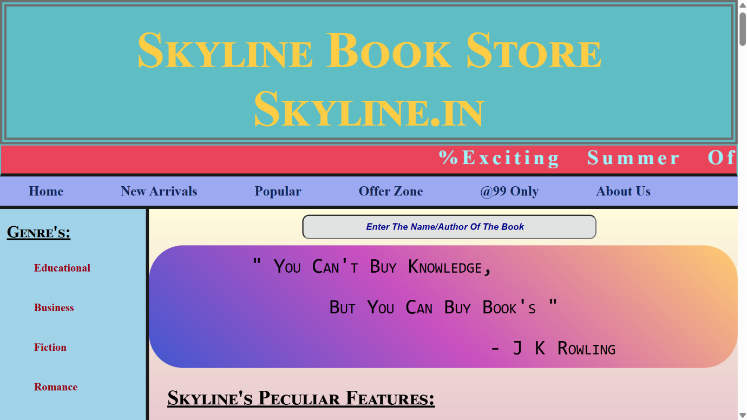

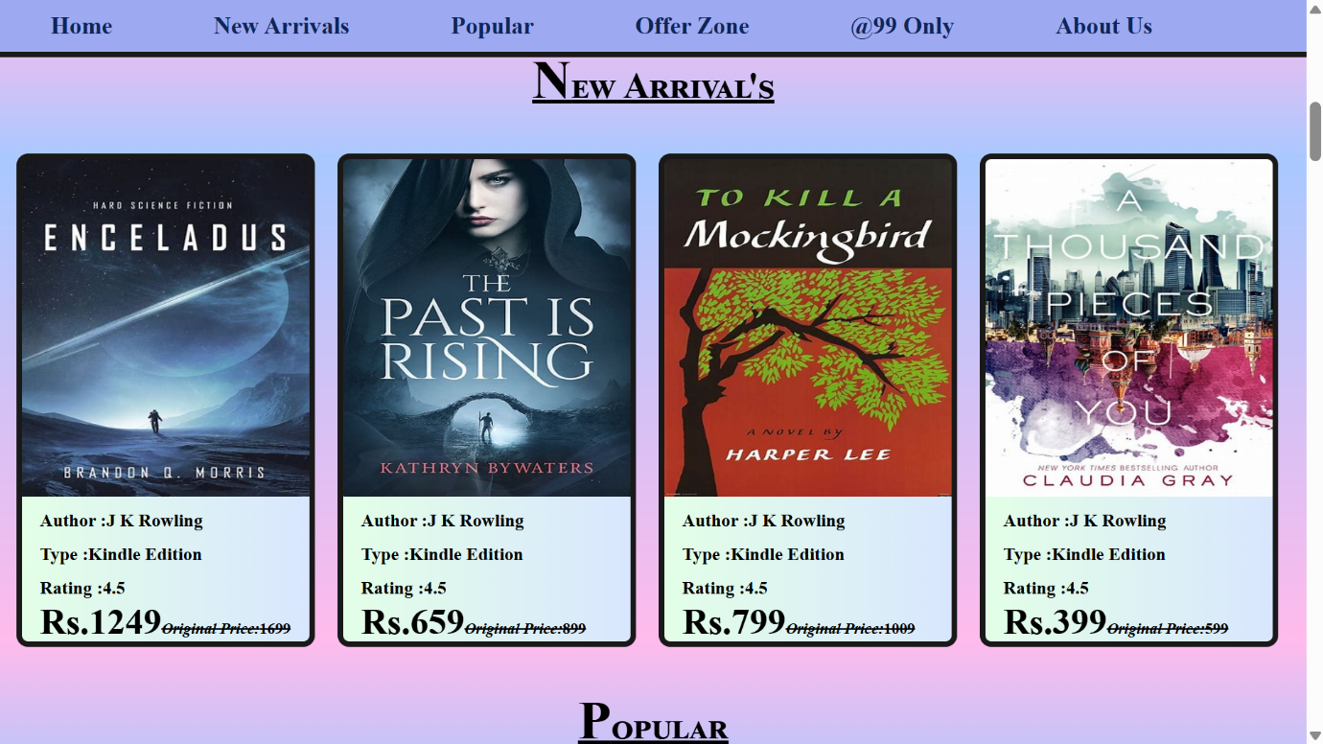

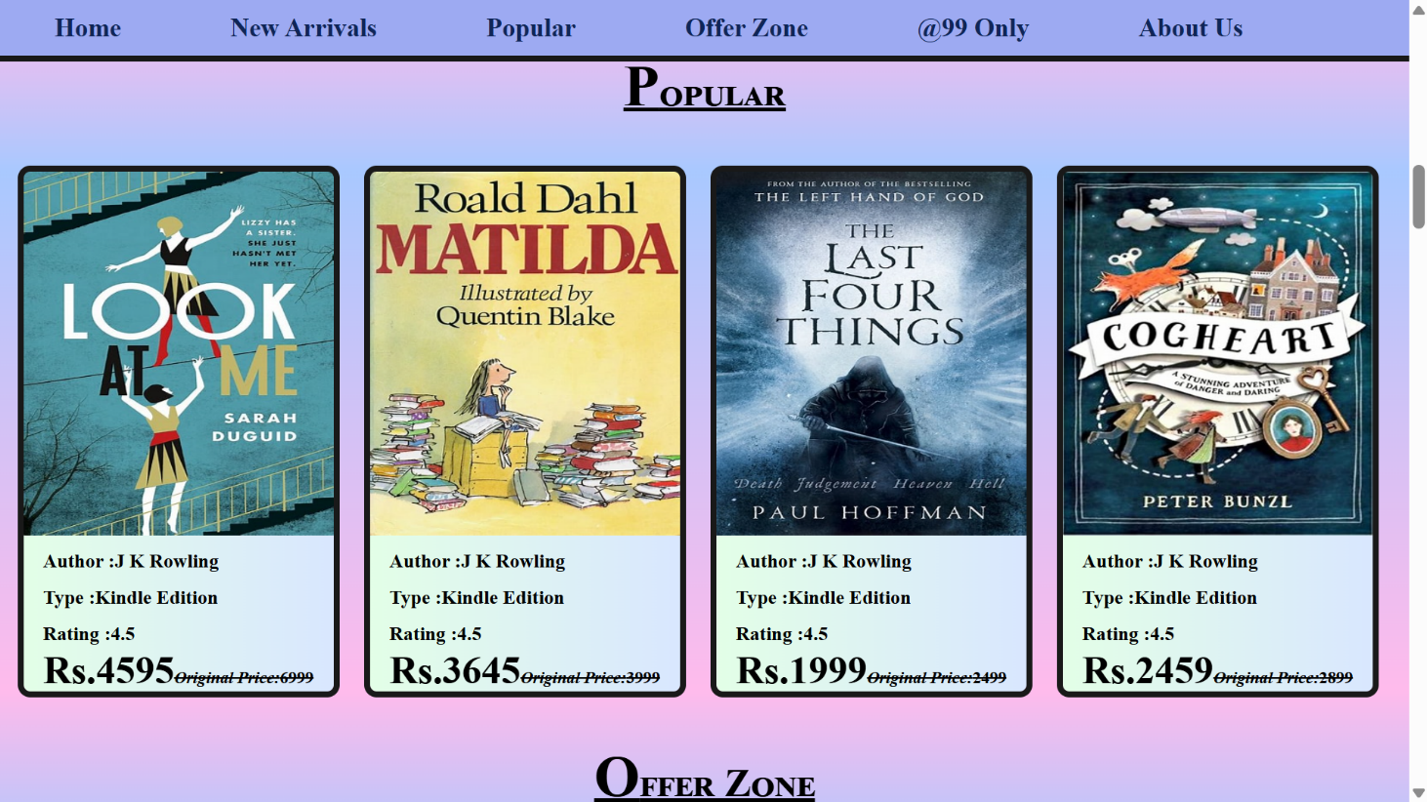

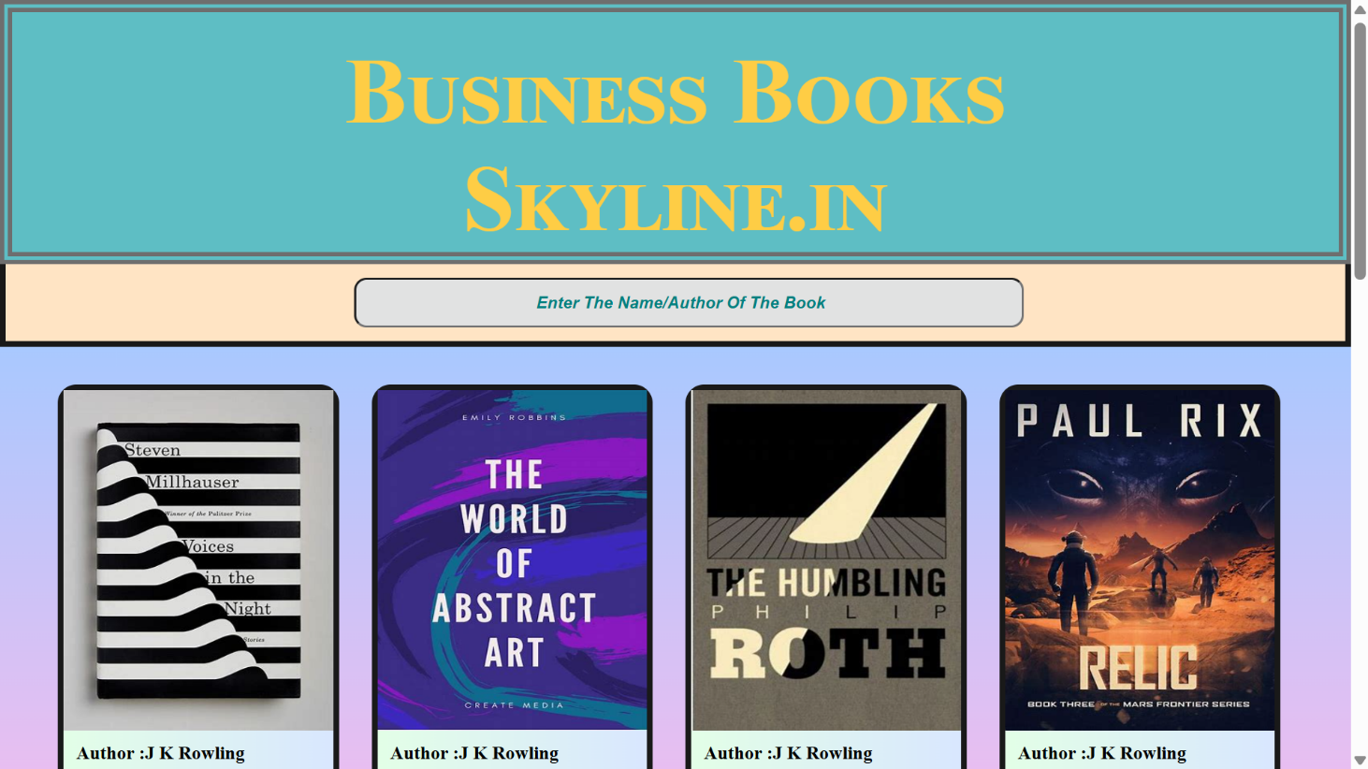

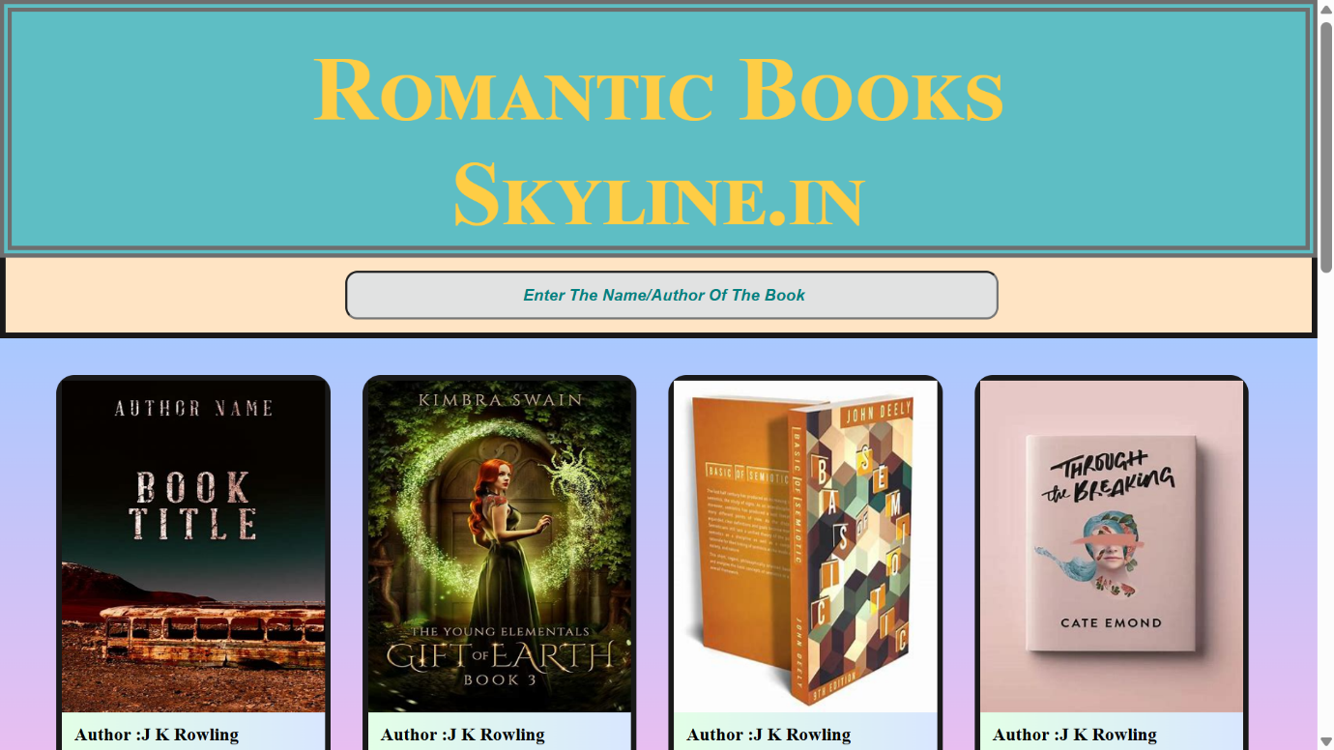

*Thank You*